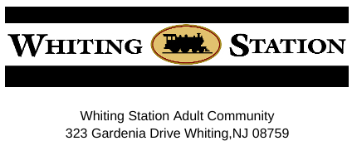
“2023 Pool Schedule & Rules”
Please note that the below schedule is subject to change at any time by the Board of Trustees or if the number of pool volunteers is not sufficient to perform daily functions.

The Whiting Station swimming pool season will begin daily on Saturday May 27 (Memorial day weekend)
Hours will be:
May,27-Aug 15, 10:00 am-8:00 pm daily
Aug,16-Sept 04, 10:00 am-7:30 pm daily

State law dictates that all swimmers must shower each time before entering the pool. Any person showing signs of skin disease, sores, or inflamed eyes will not be permitted in the pool. Personal hygienic care such as shampooing and setting hair, shaving, etc. is prohibited.

Ruled for the safety and courtesy of all residents.
- Please follow all posted sign rules
- Sign in and out when arriving and leaving the pool area
- All pool users must be diaper free and must be toilet trained. No child under the age of 3 years is permitted in the pool.
- Proper swimming attire is required for swimming. No swimming in street clothes, it is suggested that rubber soled shoes are worn in the pool area. Street clothes are permitted for non-swimmers.Have pool badges visible while in the pool area
- Pool noodles only in pool no other floating devices
- NO glass containers in the Pool area
- Place any trash in covered container
- Be courteous and wipe any tables used when leaving
- Lower umbrella if used and return seating to original locations if moved
- Smoking or Vaping in designated area only
- When using Grill Leave clean for next user
- We have a carry in carry out policy when using our BBQ grill ,that includes food,food wrappers and utensils. No cleaning of utensils in restrooms.
- Residents MUST accompany their guests while at the pool
- A Trustee or resident is empowered to enforce all Pool Rules and Regulations. Enforcement may include ejection from the pool premises for non-compliance.

As always be safe and enjoy the amenities of our great community!

