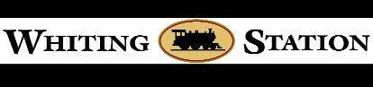

Whiting Station Adult Community

Homeowners Association Board of Trustees

October 07, 2024 7:00 pm Annual Board of Trustee Meeting

Live in Ballroom

Board Members: Mickey Ribera (Pres.), Carney Siciliano (Vice Pres.), Jon Michlaski (Sec.),

Joe Hearon (Treas.) Trustees: Batbara Hubbard, Ralph Ruggiero, Jim Farley.

Call to Order- Welcome/President's Message - *Mickey Ribera*

1. Member Q& A - *Residents*

2. Review of minutes from preceding open BOT meeting - *Vote to Approve*

3.**Annual Reports by Trustees:**

a.Treasurer - Treasurer’s report- State of finances- Joe Hearon

b.Bus & Covenants committee - Jon Michlaski.

c.Lawncare - Barbara Hubbard-

d.Architectural committee/Common Grounds - Carney Siciliano

e.Clubhouse & Pool - Ralph Ruggiero

f.Irrigation - Jim Farley

g.Residents Club - Deb Cassens

4. Election results for 2025 Board of Trustees-Lynne Sweezo

5.Presidents comments

Adjourn:

Next Meeting/Open forum , Oct 15,2024 7:00 pm Live in the Ballroom.